ASSIGNMENT – 4 DOCKER AND KUBERNETES

|  |  |
| --- | --- |
| Student Name | Sooriya S |
| Student Roll Number | 917719D096 |
| Maximum Marks | 2 marks |

Question-1: pull an image from docker hub and run it in docker playground.

1. pull an image form docker hub

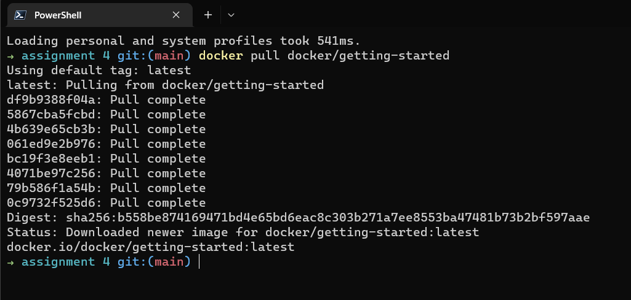

1. runt it in docker playground

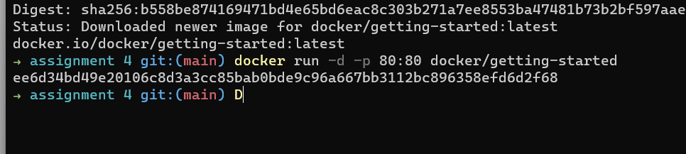

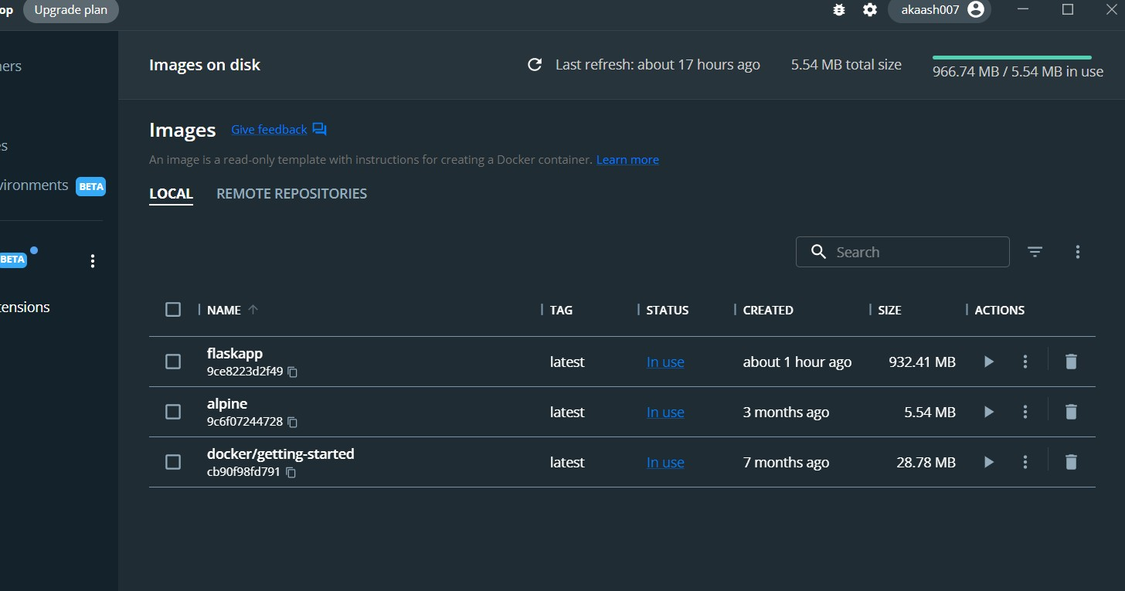

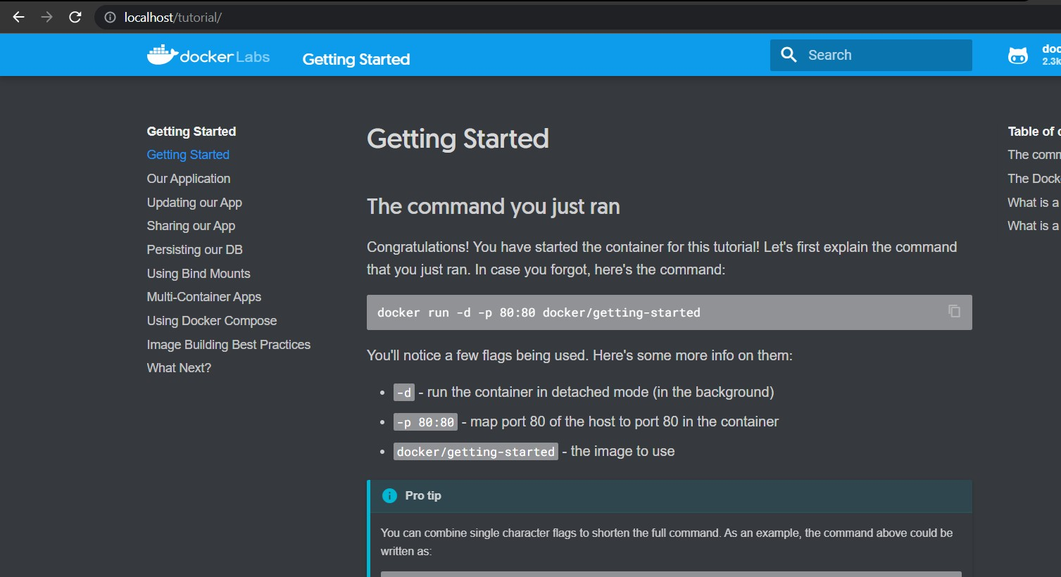

Question-2: Create a docker file for the job portal application and deploy it in docker application. 1)Creating a docker file for the job portal application

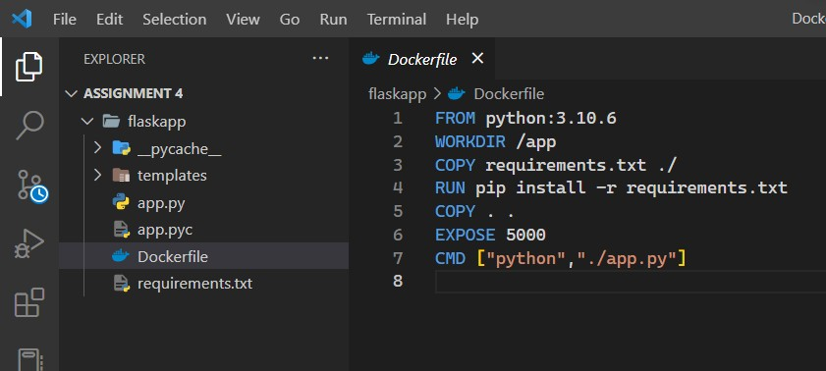

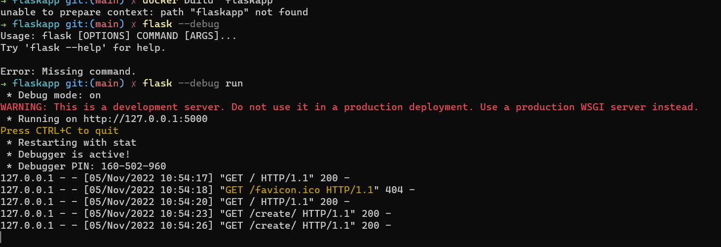

1. deploy in in docker application

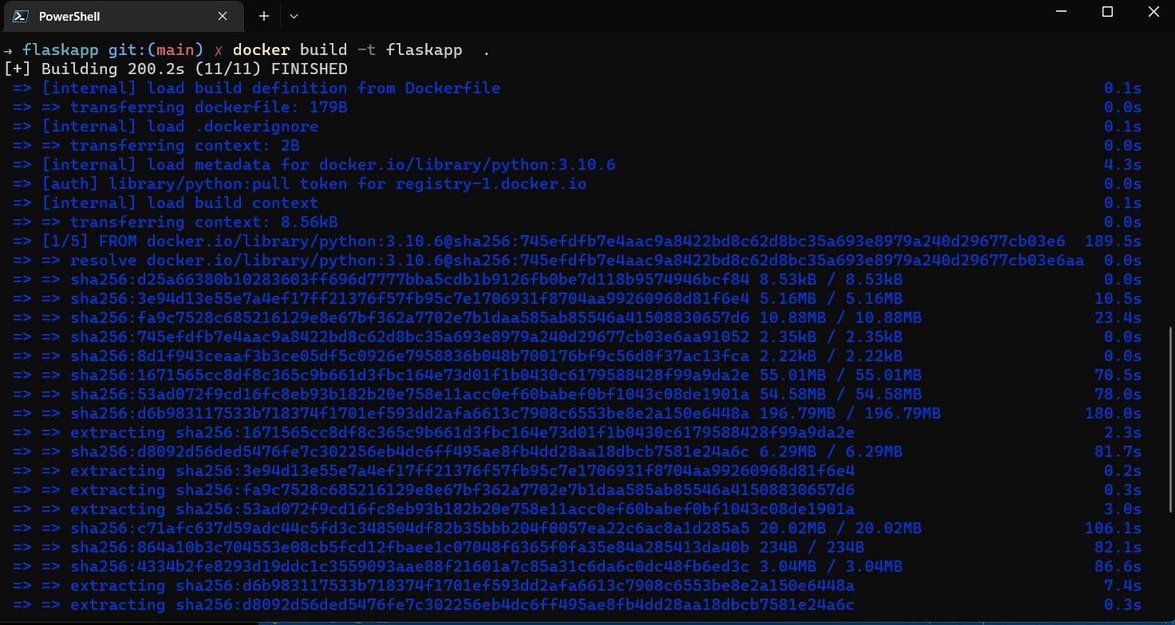

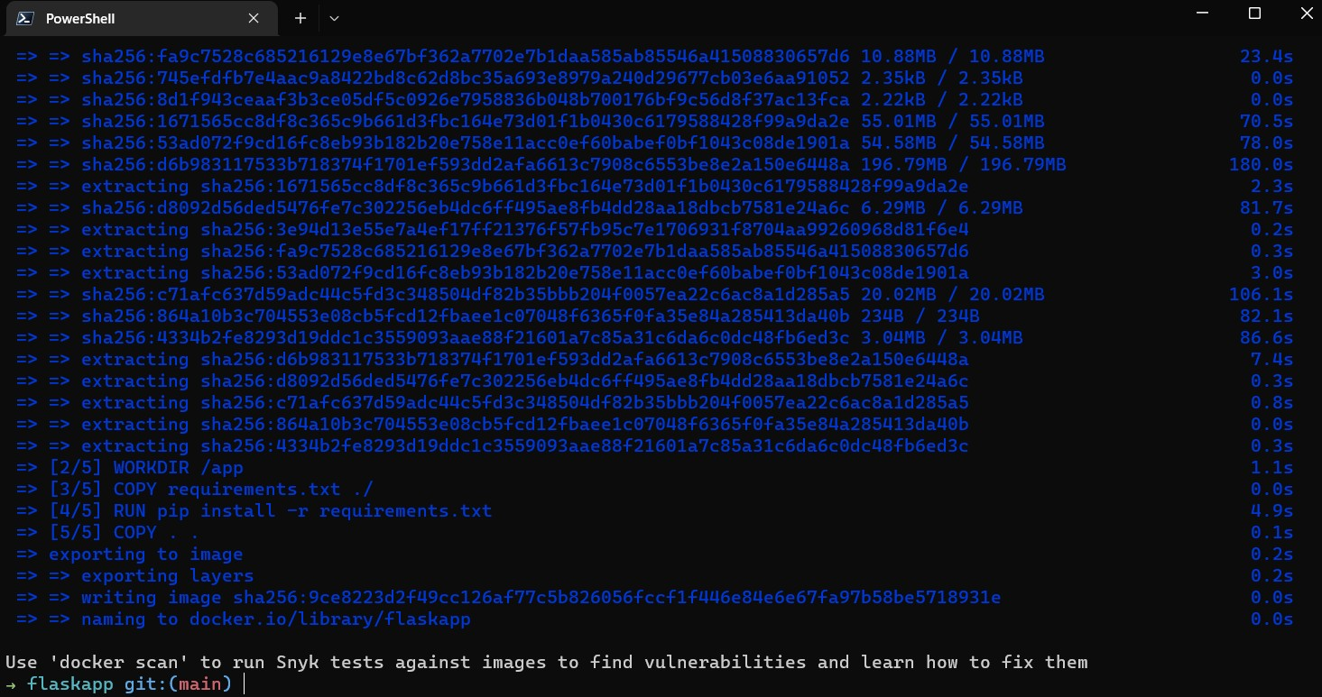

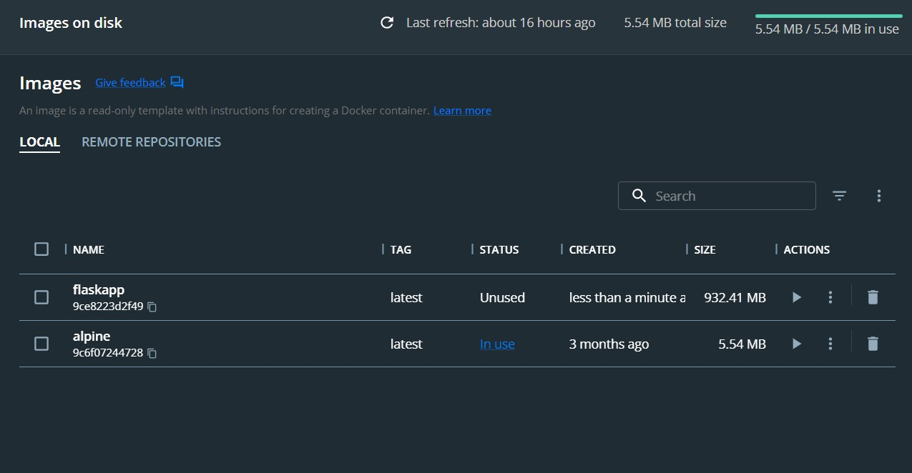

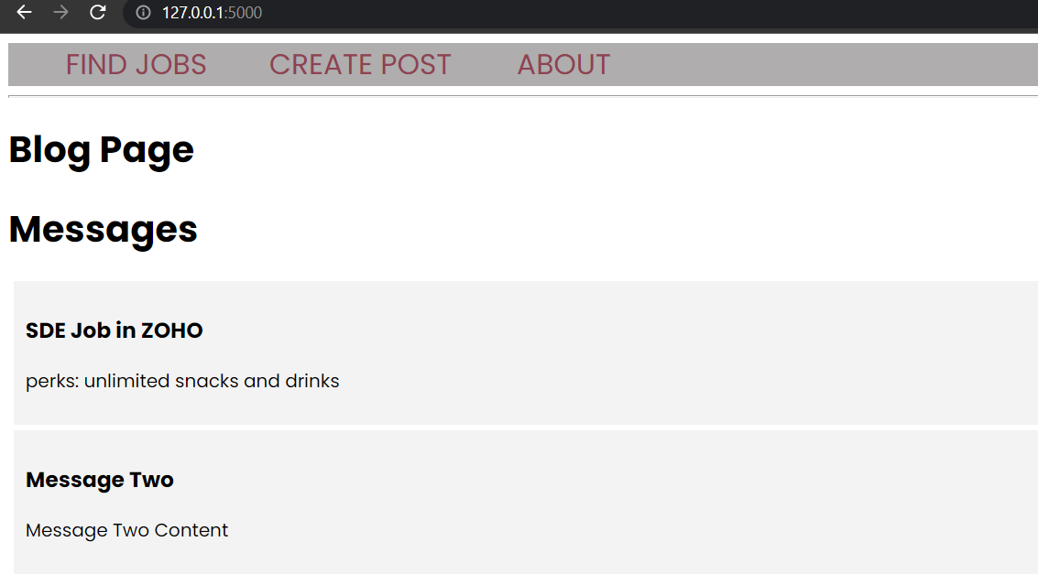

Question-3:Create a IBM container registry and deploy hello world app or jobportalapp

* 1. create a IBM container registry

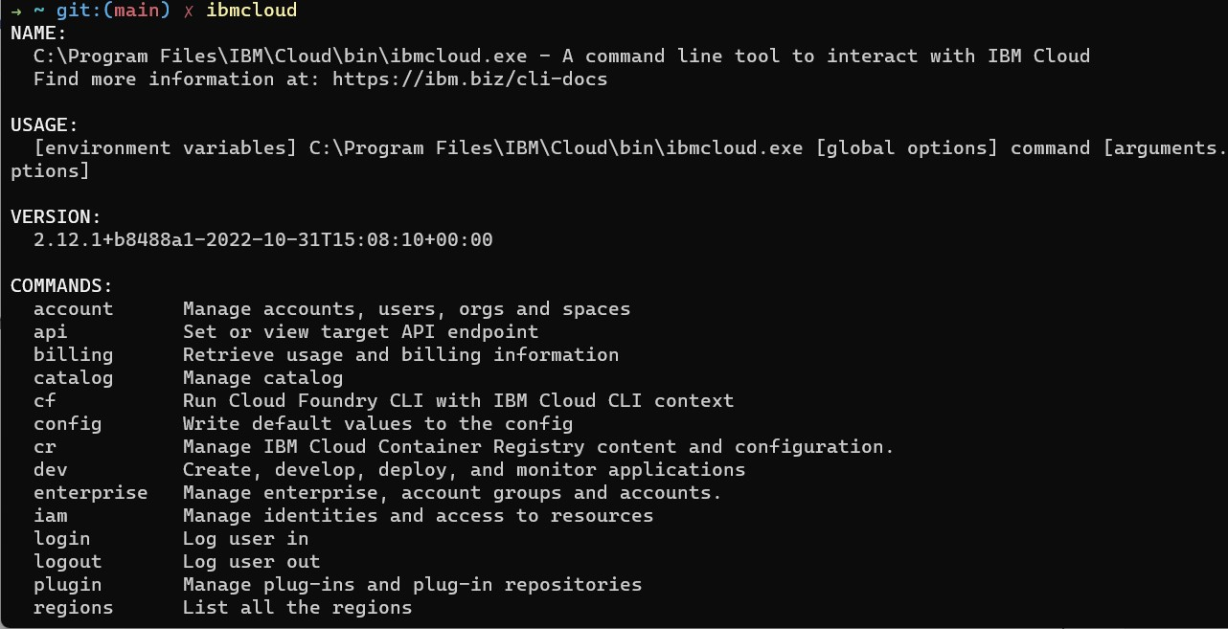

* 1. deploy hello world or jobportal

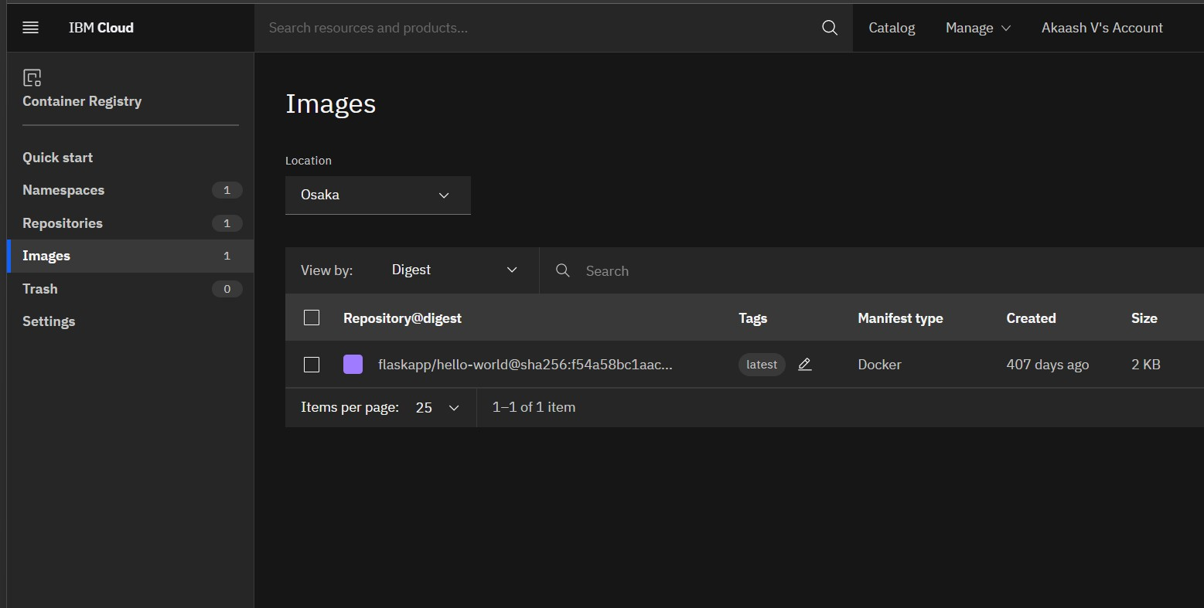

Question-4: Create a Kubernetes cluster in IBM cloud and deploy helloworld image or jobportal image and also expose the same app to run in note port

1)Creating a Kubernetes cluster in IBM cloud

